ABCs of Evaluating Evidence Grades 7 & 8

 | PROCEED  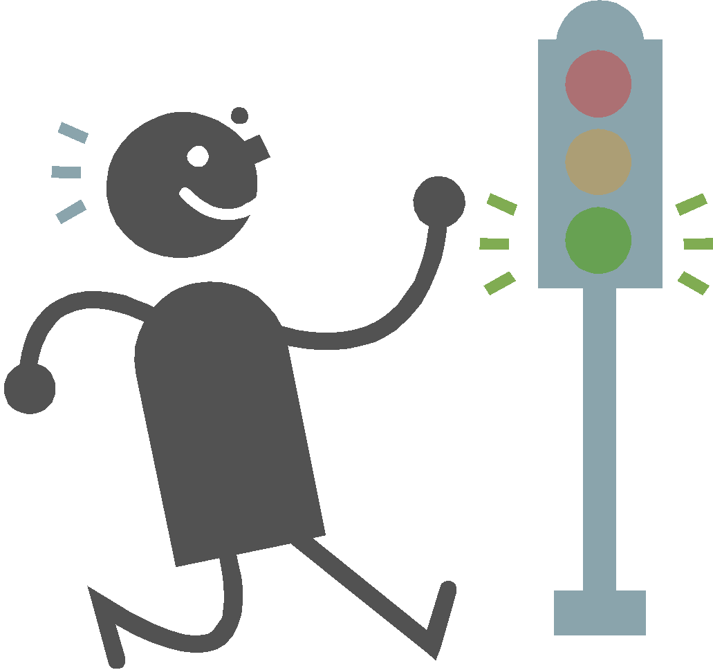  VERIFIABLE, CREDIBLE, RELIABLE | USE WITH CAUTION  POSSIBLE PROBLEMS | WARNING  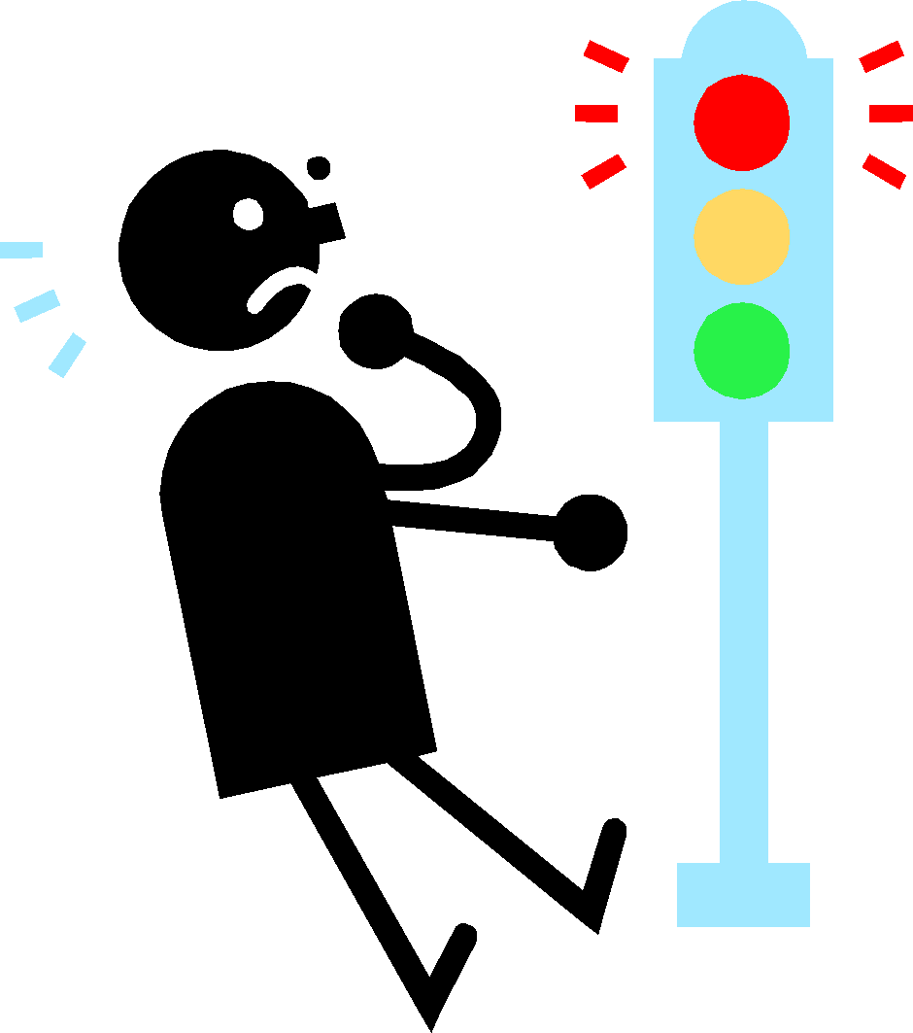  SHOULD BE SKEPTICAL
Author or Sponsor (an organization may be the author) | Author’s name is present.  Author is qualified in this field.  If a web page, it is posted by a credible group: university, agency, etc. | Author is named, but searching may be necessary to locate the author.  Author is not clearly qualified in this field.  If a web page, the credibility of the source/ host of the page is unknown. | Author’s name is missing.  If named, author’s credentials missing.  Publication has an explicit or implicit agenda and/or offers extremist views.  If a web page, the source/host is of questionable reputation or may be known for strong biases.
Balance & bias  of perspective or presentation | Arguments and evidence are presented objectively.  Facts, not opinions, are provided  Counterarguments are acknowledged and answered fairly. | Arguments and evidence sometimes include opinion & slight bias.  Both facts and opinions are included, but it is easy to tell them apart.  Counterarguments are incomplete or inconsistently offered. | Arguments are obviously opinions or are extremely biased.  Opinions outnumber and outweigh facts  Opposing arguments are countered with name-calling or inappropriate attacks on the person.
Content & Conventions | Evidence is sufficient, clear and specific.  Evidence is cited or is original research.  Evidence is explained or analyzed.  Conventions (spelling, capitalization, punctuation, and grammar) are always correct | Evidence is offered, but may be general.  Evidence is only sometimes cited.  Evidence is inconsistently explained or analyzed.  Conventions (spelling, capitalization, punctuation, and grammar) are almost always correct | Evidence is missing for several points.  Evidence is misleading - seems presented for shock value or is purely emotional.  Misleading graphs, illustrations, photos, or headlines are offered as evidence.  Source of evidence is not presented.
Date appropriate  for the discipline | Source offers the date published  (& revision date if electronic.)  Information is current according to the standards of the discipline. | Dates are present, but may not represent the date the information was actually produced or written (for example: copyright range of years 2008-2013).  Information is marginally within the discipline’s standards for currency. | Source offers no date of publication or revision.  Information is clearly older than the discipline’s standards for currency.

Please list your sources below and for each letter describe how you determined the source to be worthy of using in your paper based on the ABC chart above.

Source 1 Citation: ________________________________________________________________________________________________________________________

A:

B:

C:

D:

Source 2 Citation: ________________________________________________________________________________________________________________________

A:

B:

C:

D:

Source 3 Citation: ________________________________________________________________________________________________________________________

A:

B:

C:

D:

Source 4 Citation: ________________________________________________________________________________________________________________________

A:

B:

C:

D:

